Assignment 4: Introduction to VPNs
Topic: Types of VPNs — Site-to-Site, Remote Access, Practical Configuration in Packet Tracer
Shreya Panchal

Theory Overview

1. What is a VPN (Virtual Private Network)?
A Virtual Private Network (VPN) creates a secure, encrypted connection over an insecure public network like the internet. It works by wrapping private data packets inside a public transport protocol layer, ensuring data privacy, integrity, and authenticity between remote networks or individual users.

2. Primary Types of VPNs
• Site-to-Site VPN: Connects entire networks to each other — for example, a branch office network to a company headquarters. Dedicated network devices like routers or firewalls handle all encryption and decryption transparently for the local users.
• Remote Access VPN: Connects individual users to a secure enterprise network. Employees working from home run a VPN client application on their computers or smartphones to log in and access internal company servers.

Tasks & Answers

Task 1: Basic IP Addressing & LAN Connectivity
Question: In Cisco Packet Tracer, create two separate networks (representing two branch offices) using two routers and configure basic IP addressing so that each network can ping its own devices.
Answer: To set up this topology, we configure the local interfaces (LAN and WAN) on both routers.
• Branch 1 Subnet: 192.168.10.0/24 (Gateway: 192.168.10.1)
• Branch 2 Subnet: 192.168.20.0/24 (Gateway: 192.168.20.1)
• Public Inter-Router Subnet: 203.0.113.0/30
Configuration on Router_A (Branch 1):
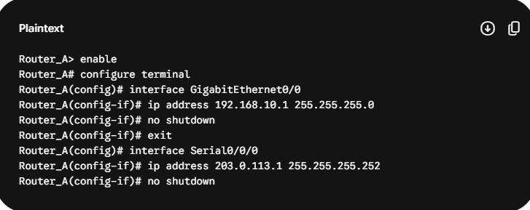
Configuration on Router_B (Branch 2):
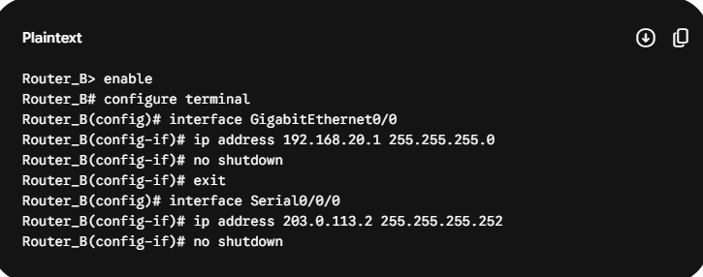
Verification: PCs in Branch 1 can successfully ping their local gateway (192.168.10.1), and PCs in Branch 2 can successfully ping their gateway (192.168.20.1).

Task 2: Site-to-Site GRE Tunnel Configuration
Question: Configure a basic site-to-site VPN between the two routers in Packet Tracer using GRE tunnel interfaces and assign tunnel IP addresses so that PCs from one branch can ping PCs in the other branch. Hint: Use the “interface tunnel” command on both routers and set the tunnel source and destination to the routers' public-facing interfaces.
Router_A (Branch 1 VPN Setup):
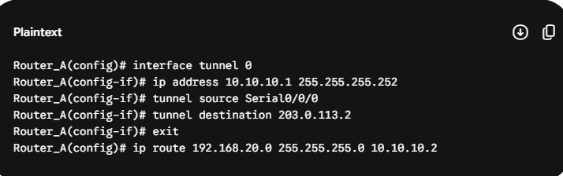
Router_B (Branch 2 VPN Setup):
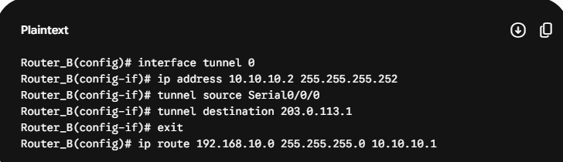
Verification: Opening the Command Prompt on a PC in Branch 1 (192.168.10.10) and running ping 192.168.20.10 returns successful replies, confirming the GRE tunnel is routing the cross-branch traffic correctly.

Task 3: Remote Access VPN Client Simulation
Question: Simulate a remote access VPN scenario in Packet Tracer by configuring a VPN client PC to connect securely to one of the branch routers using the built-in VPN client feature. Use the VPN tab on the PC and set the correct server IP, username, and password.
Step 1: Set up the Local Database and IP Pool on Router_A
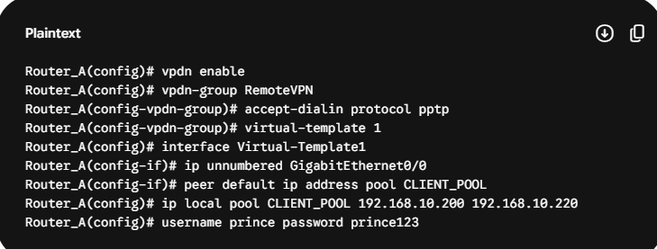
Step 2: Connect the Remote PC Client Application
• Click on the Remote Client PC inside Packet Tracer and open the Desktop Tab.
• Open the VPN application tool icon.
• Map the parameters as follows:
• VPN Server IP: 203.0.113.1 (Public facing Serial interface of Router_A)
• Username: prince
• Password: prince123
Click Connect. The status changes to “Connected”, and the PC receives a virtual IP (192.168.10.200), granting secure access to internal devices.

Task 4: Site-to-Site VPN vs. Remote Access VPN
Question: List and explain the main differences between site-to-site VPN and remote access VPN based on your Packet Tracer configurations, including at least two advantages and disadvantages of each approach.
Comparison Parameter | Site-to-Site VPN | Remote Access VPN
Primary Connection Type | Permanent connection between fixed locations (Branch to HQ). | On-demand connection between a single mobile user and corporate HQ.
Hardware / Client Needs | Handled completely by routers/firewalls; no user apps required. | Requires specialized VPN client software installed on the user's OS.

Site-to-Site VPN Evaluation:
Advantages:
• Completely Transparent: Traffic encrypts automatically at the gateway level; users don't need to log in manually.
• High Infrastructure Stability: Always-on tunnel ensures constant availability between regional databases.
Disadvantages:
• Zero Mobility: Restricted to fixed company facilities; traveling or work-from-home users cannot connect.
• High Deployment Cost: Requires purchasing corporate routing or firewall hardware at every physical branch.

Remote Access VPN Evaluation:
Advantages:
• Excellent Workforce Flexibility: Employees can connect securely to office servers from any location with an internet connection.
• Cost-Efficient Scale: No hardware needs to be shipped to employee homes; uses software clients to handle validation.
Disadvantages:
• End-Device Security Vulnerabilities: If an employee's personal device contains malware, it could compromise the corporate internal network upon connection.
• High Administrative Overhead: Relies on manual user connections, which leads to more IT support calls for password resets or connectivity bugs.

Task 5: Document and Submit Configuration Script
Question: Document and submit the step-by-step configuration commands you used to set up the site-to-site VPN in Packet Tracer, including interface, tunnel, and routing commands.
This matches the detailed implementation steps documented in Task 1 and Task 2 above. The consolidated script below is presented clean for submission records:
